

Accompanist How-to

OC Performance Scheduling

Oklahoma Christian University

Table of Contents

Process Overview 2

1. Event Flow 2

a. Prior to the Event Day 2

Functionalities 3

1. Login Steps 3

a. Login 3

b. First Time User or in the Semester 6

2. Home Page 7

3. Event Availability 9

a. Add Availability 9

b. Edit Availability 11

c. Delete Availability 13

4. Logout 15

# Process Overview

## Event Flow

### Prior to the Event Day

* The event (recital hearing, jury, etc.) has been set up and now accompanists need to indicate what time during the event that they will be available.
* You should go to the event and **enter your availability.**
* **Find the event** on the “Upcoming Events” column on the Home Page.
* Click on “**Add Availability**” for that event.

# Functionalities

## Login Steps

### a. Login

* Navigate to the [Performance Scheduling website](https://performance.oc.edu/) (click on this link that goes to <https://performance.oc.edu/>).
* We use Google to authenticate our logging in.
* You must use your OC affiliated email address to login.
  1. Click Sign up with Google.

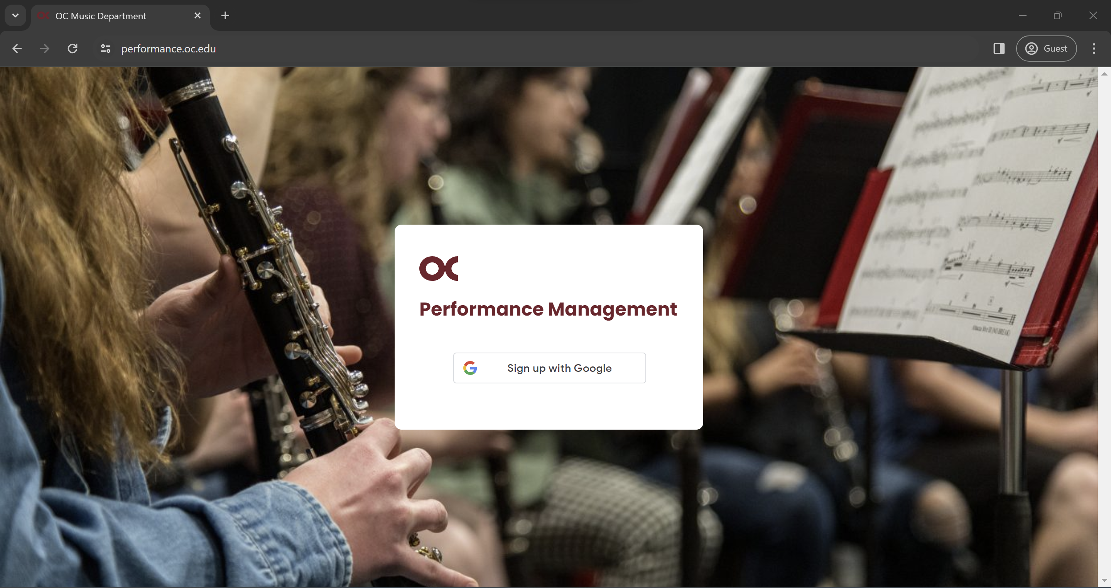

* 1. Enter your **OC** email.

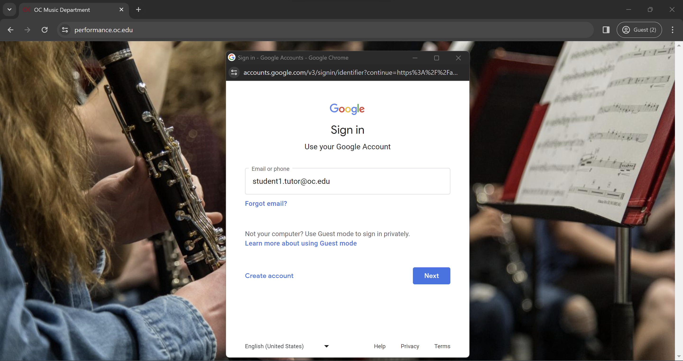

* 1. Enter your **OC** credentials.

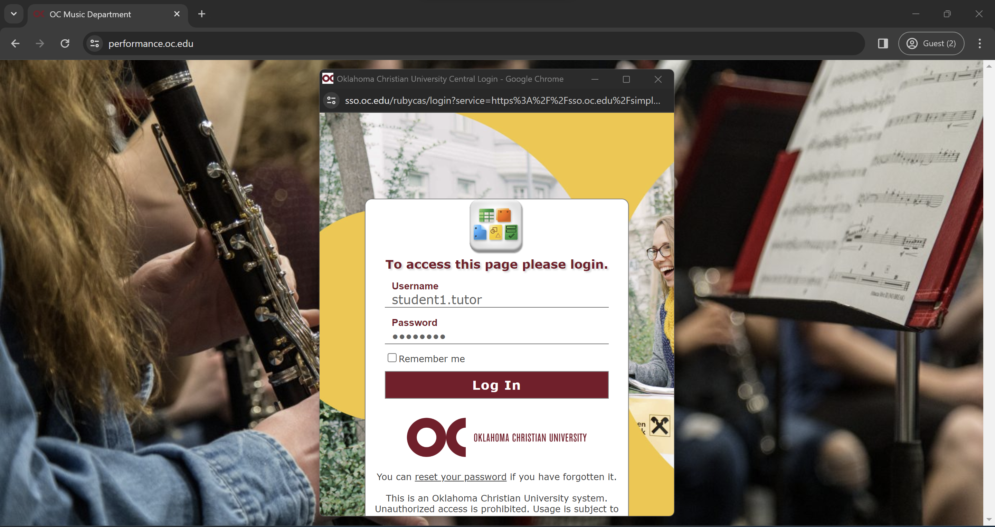

* 1. Click on the account you logged in with.

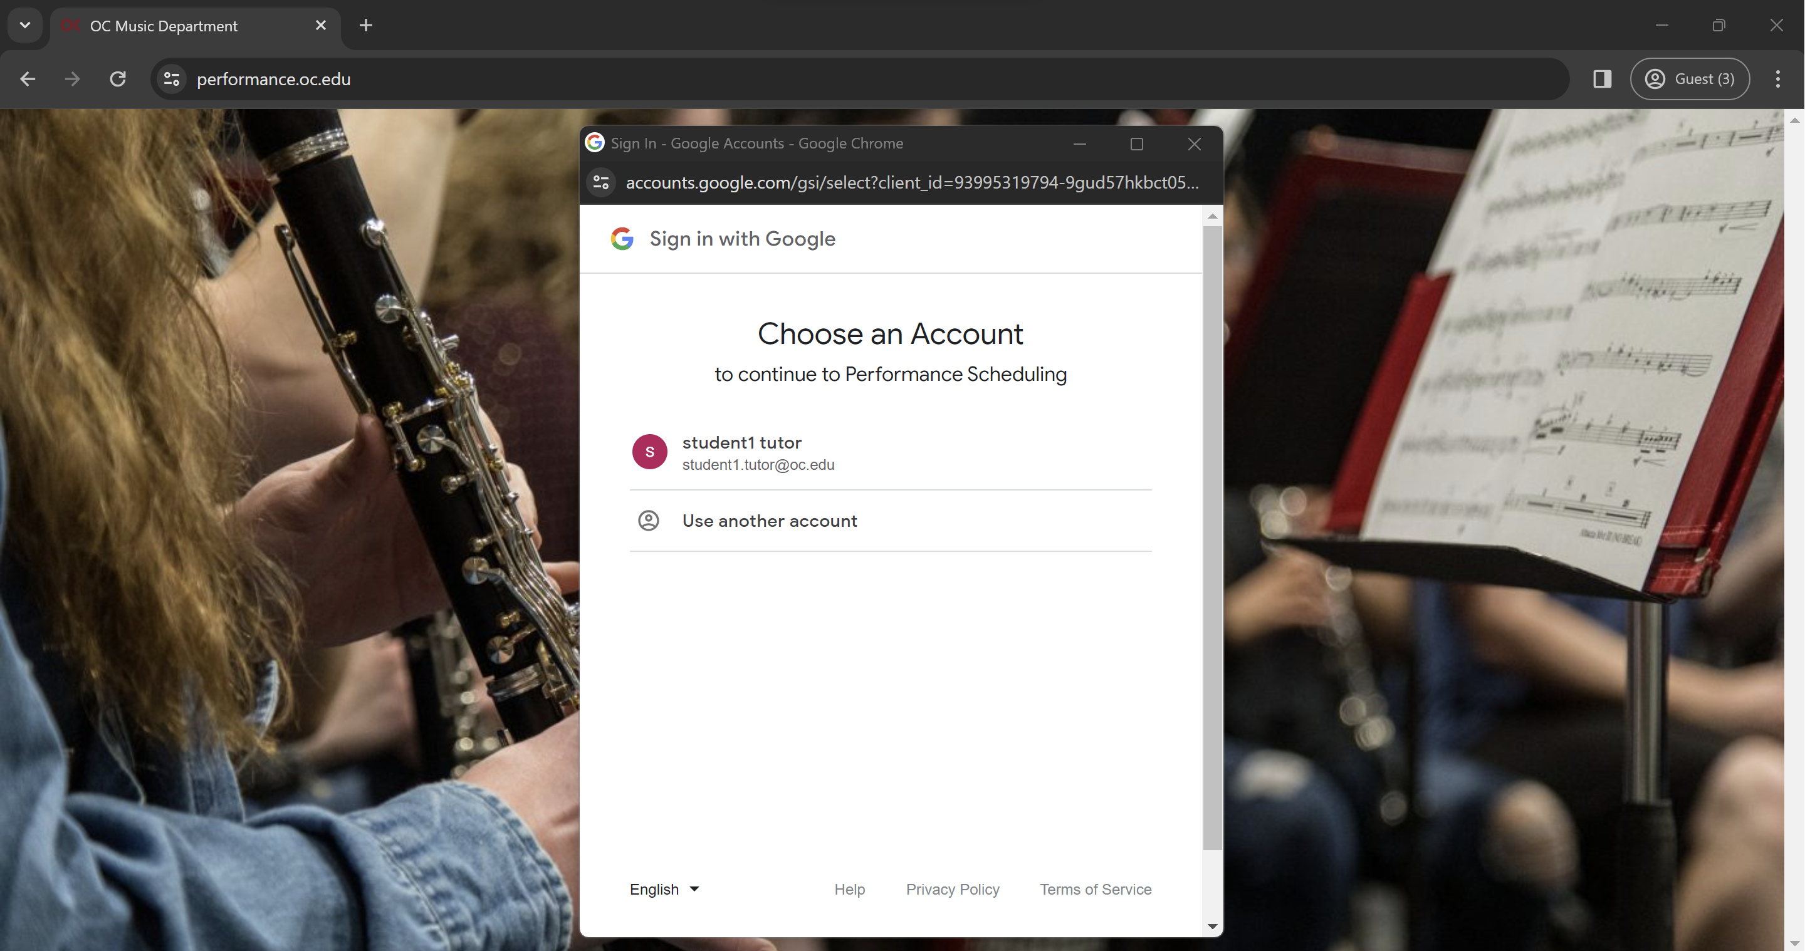

* 1. Google may ask you to give permission to share information with this site. If it does, please give the permission.

### b. First Time User or in the Semester

* When you log in for the first time, you must update your profile information.
* If you are logging in for the first time on the semester, make sure your information is updated.
  1. Click on Accompanist and then User Settings.

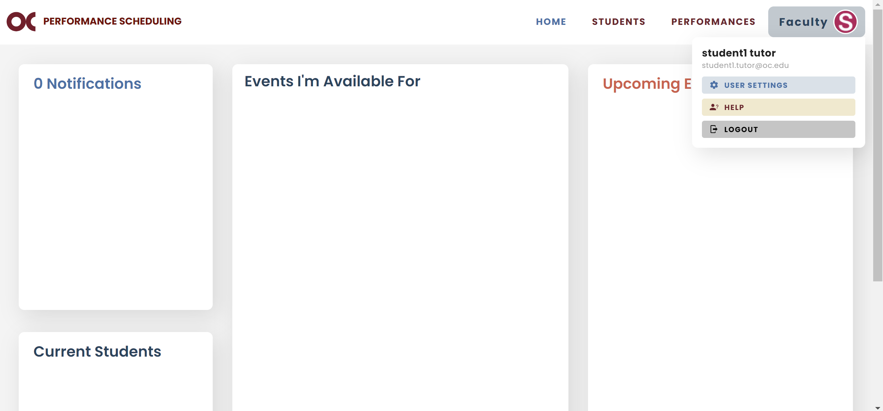

* 1. Update your profile information and click Save.

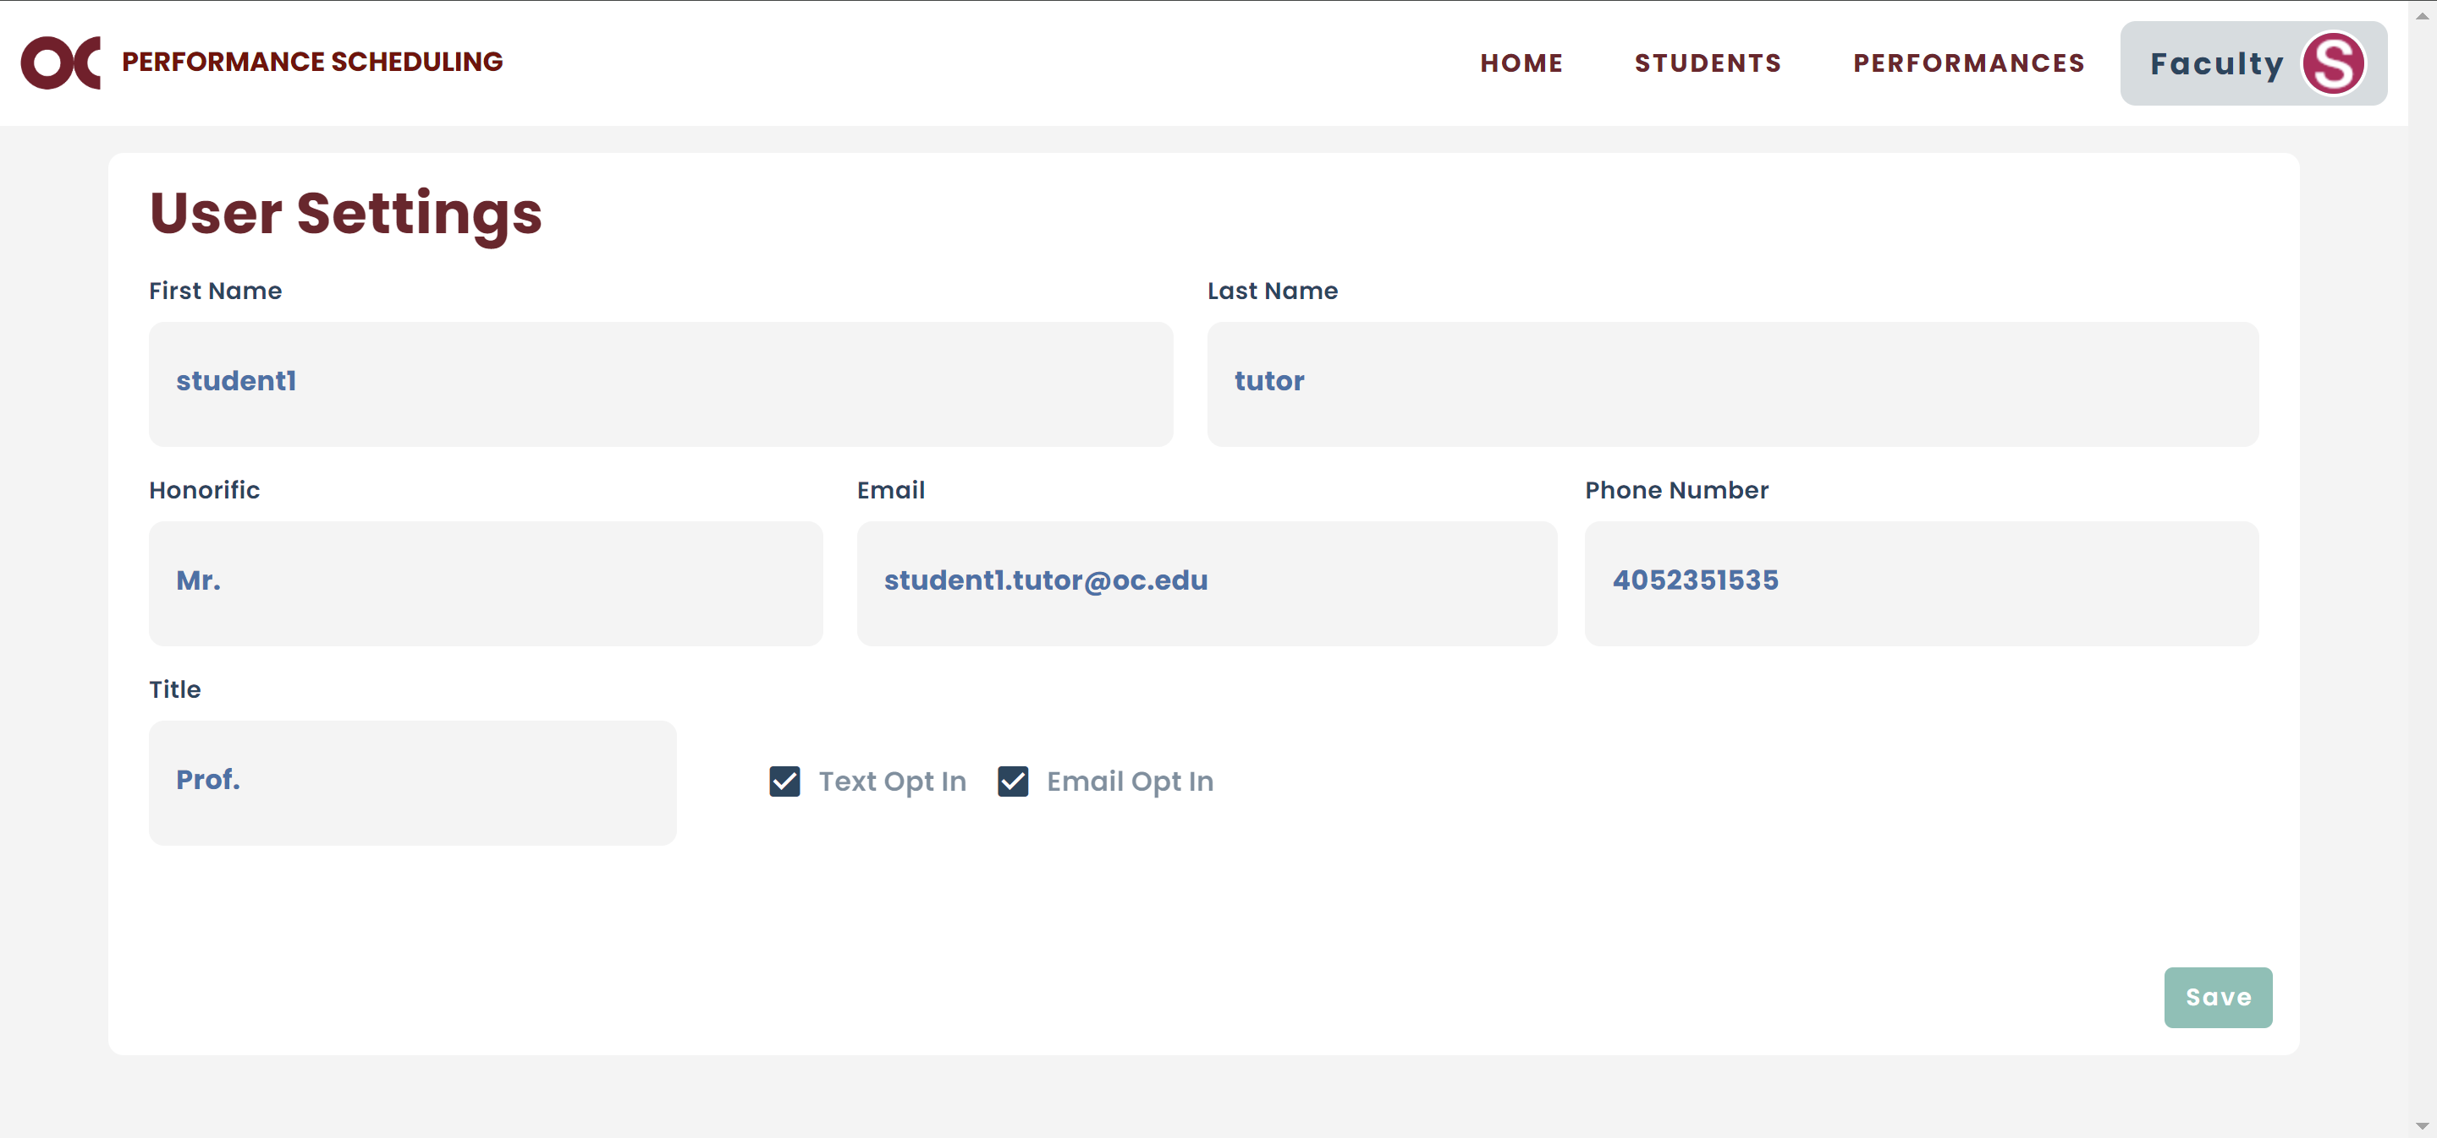

## Home Page

* Home Page is divided into four columns.
* The Upcoming Events column will display all the events that will happen in the future.

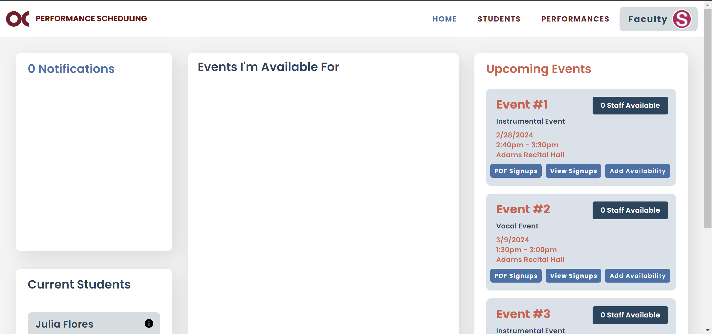

* The Events I’m Available For column displays the information about all the events that you will be present and have entered the time you will be available for.

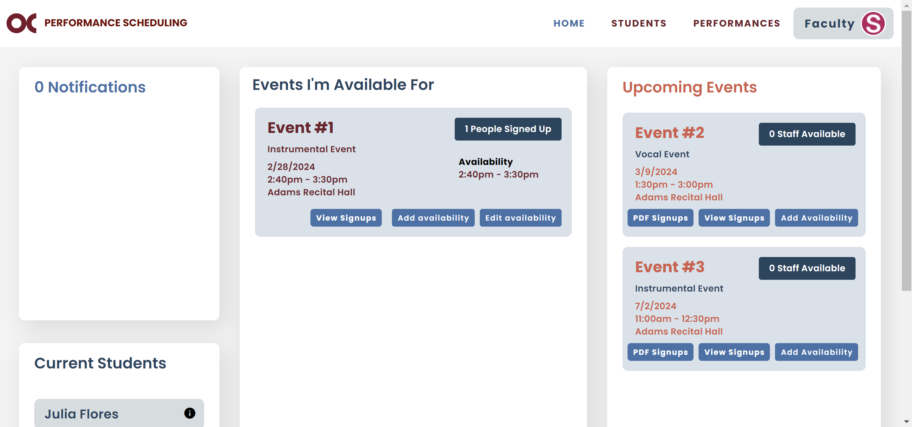

* The Notifications column will display notifications from requests that students have made for you to adjust your availabilities. It will display the requester’s name and the event information. You will also receive an email about it.

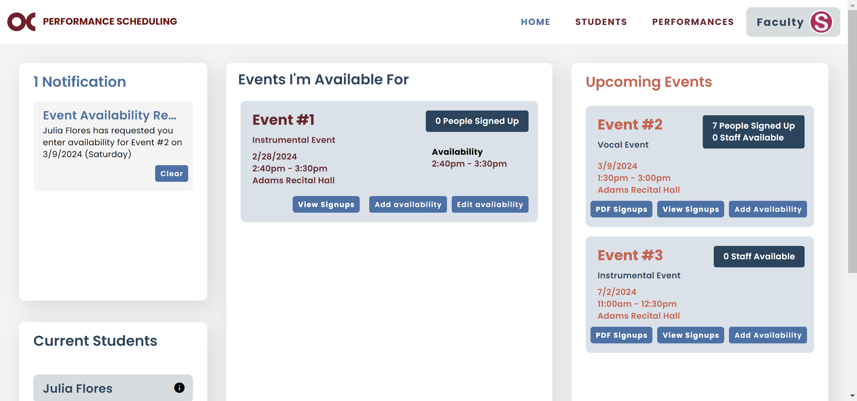

* The Current Students column displays the name of the students you are an accompanist for on the current semester.

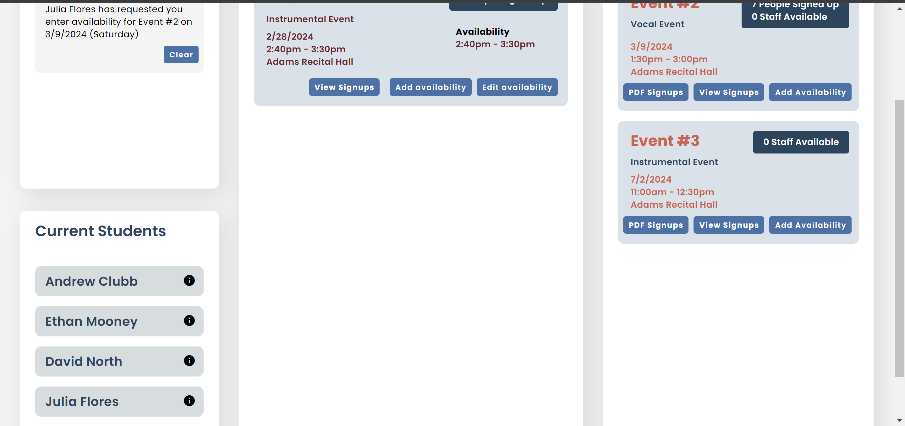

## Event Availability

* This is the part where you will confirm that you will be present at a certain event.

### a. Add Availability

* 1. To do so, you will go to the Upcoming Events column and find the event.



* 1. Once you find it, click “Add Availability”.



* 1. The following screen will pop up.

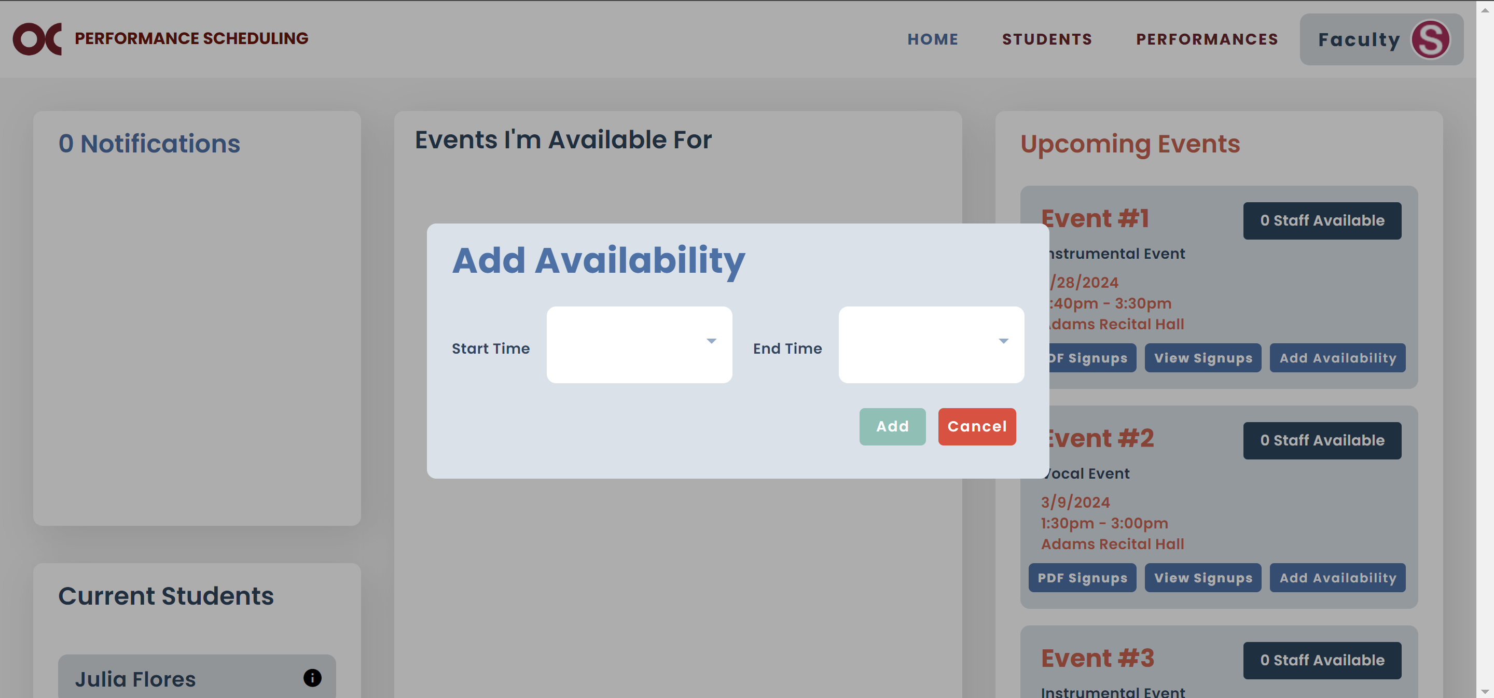

* 1. Enter the time that you will be available for that event and click “Save”.

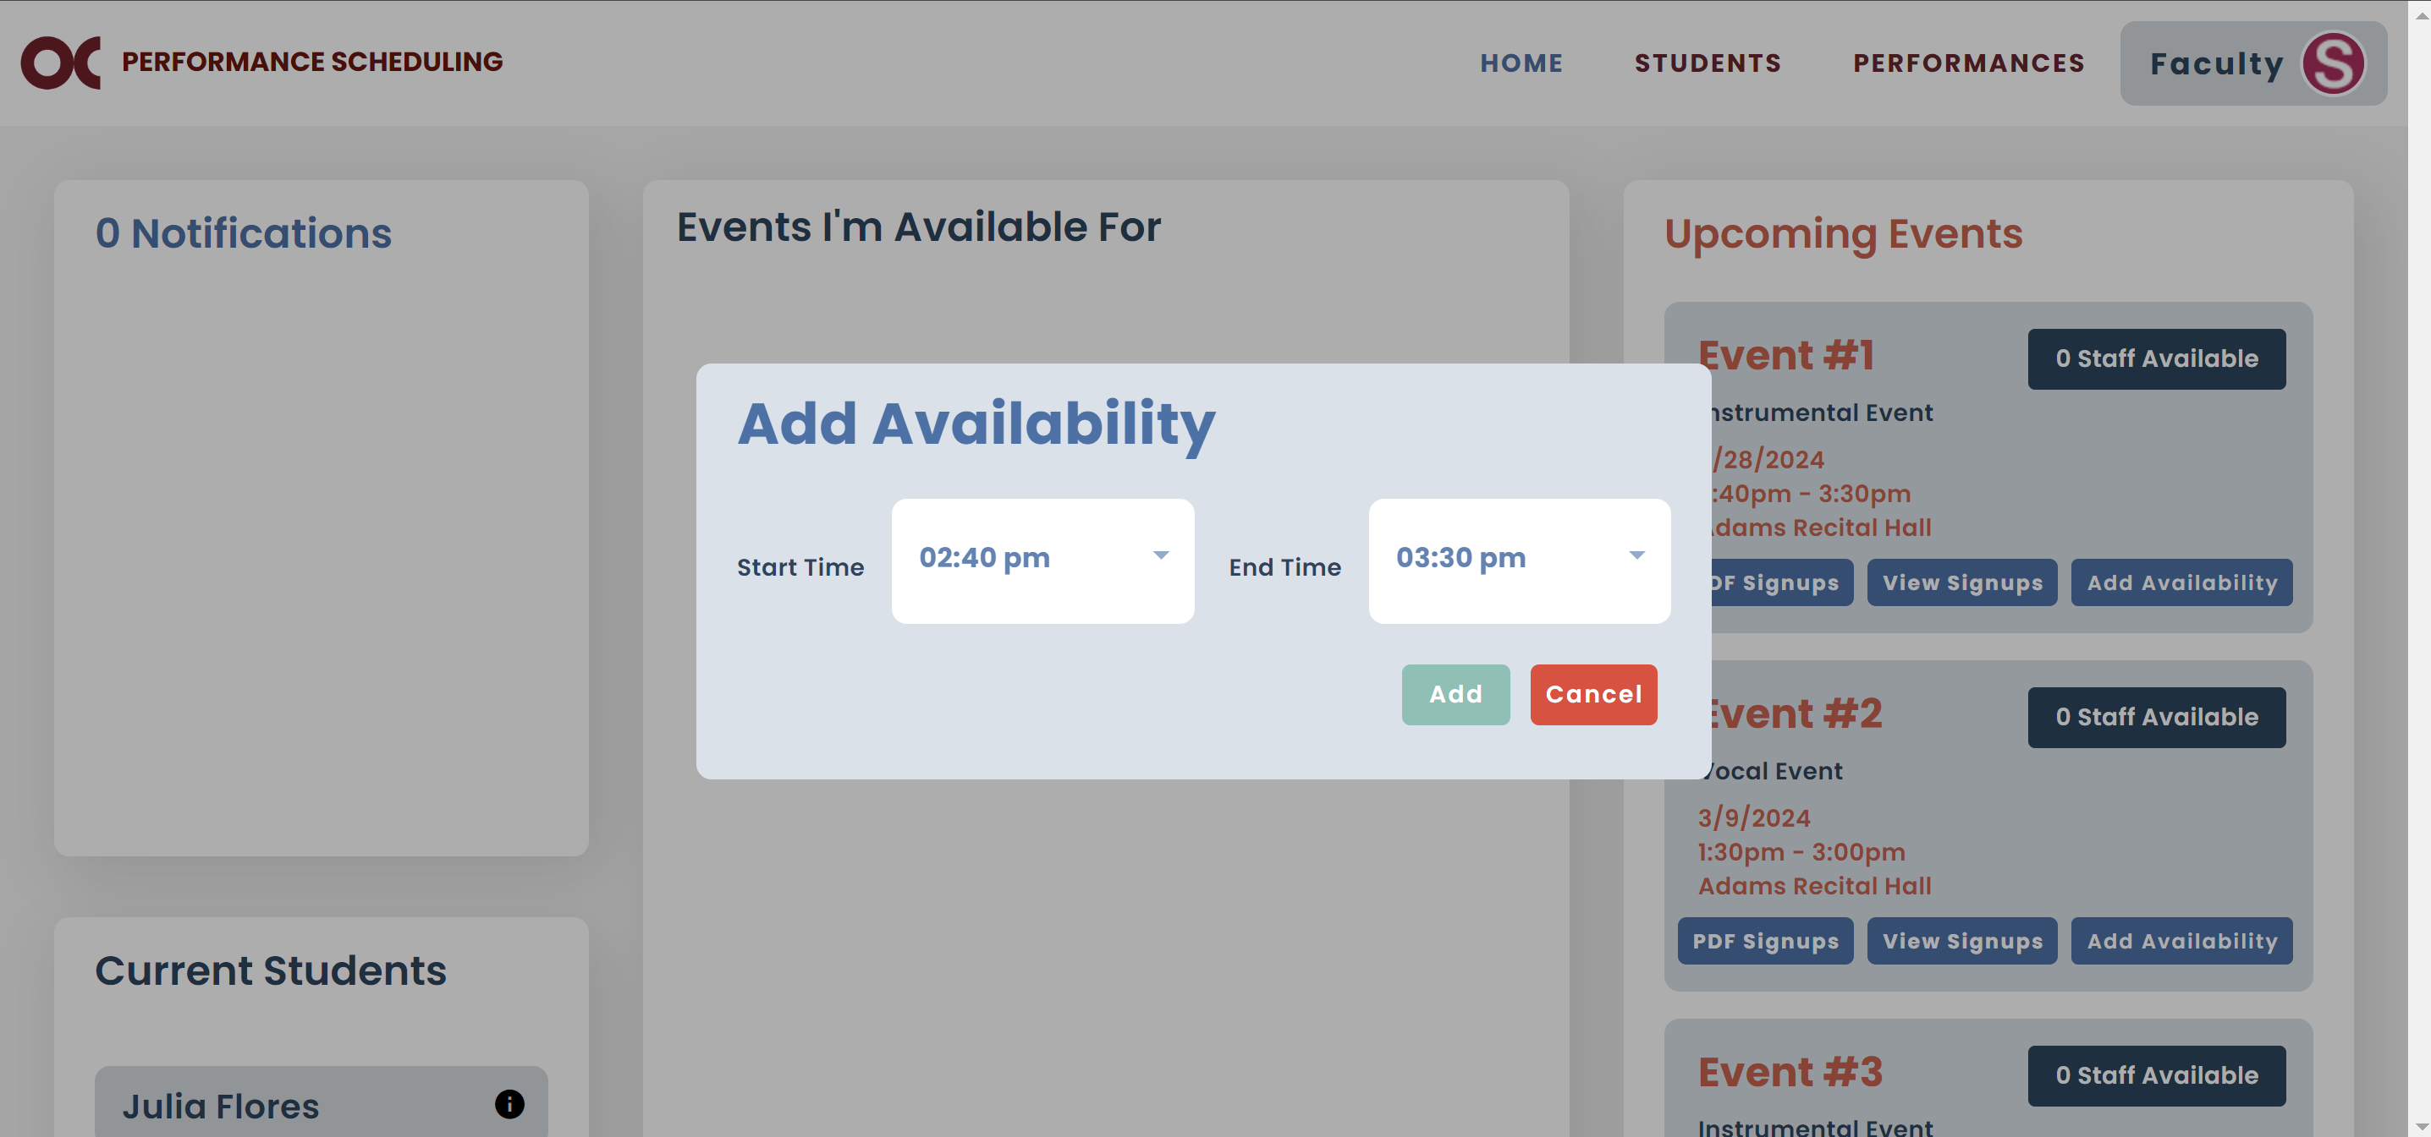

### b. Edit Availability

* If want to change the time that you entered to be available for a certain event.
  1. Go to the Events I’m Available For column and find the event.



* 1. Click on “Edit Availability”.



* 1. The following screen will pop up.

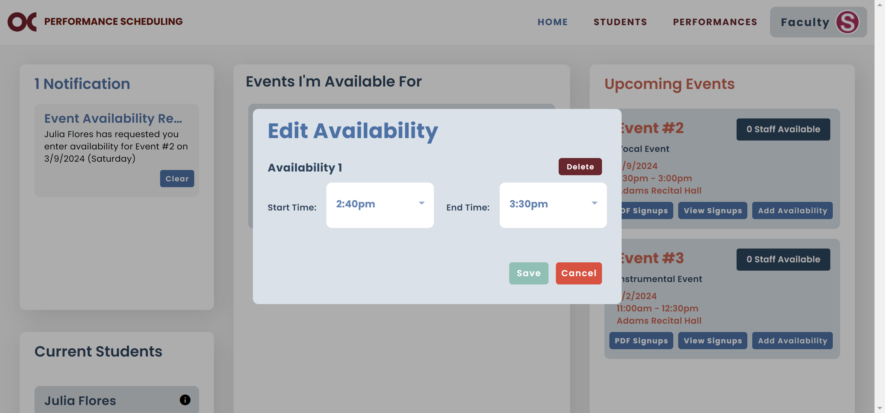

* 1. Make your changes and after you are done, click “Save”.



### c. Delete Availability

* If you will not be able to go to a certain event anymore.
  1. Go to the Events I’m Available For column and find the event.



* 1. Click on “Edit Availability”.



* 1. The following screen will pop up.



* 1. Click “Delete”.



## Logout

* Click on Accompanist and then Logout.

